ABC Dog Grooming Cost sheet

Student: Brian Johnston

Class: CGS2823

|  |  |
| --- | --- |
| Item | Cost |
| New Website Design (5 pages 45 hours)  Included:  Custom Design  Storyboards  2 different home page comps  Customer and Task analysis  1 photo Gallery  1 Contact/Appointment Form | $1275 |
| Logo Design | $275 |
| Hosting Package(1 year special pricing Go Daddy) | $95.88 |
| Maintenance Package(opted out) | $0 |
| Optimization | $250 |
| Search Engine Submission | $75 |
| Admin time(4 hrs) | $125 |
| Sub Total | $2095.88 |
| Sales Tax | $146.71 |
| Total | $2248.59 |

Layout 1: (Note banner will change to an image when layout is chosen)

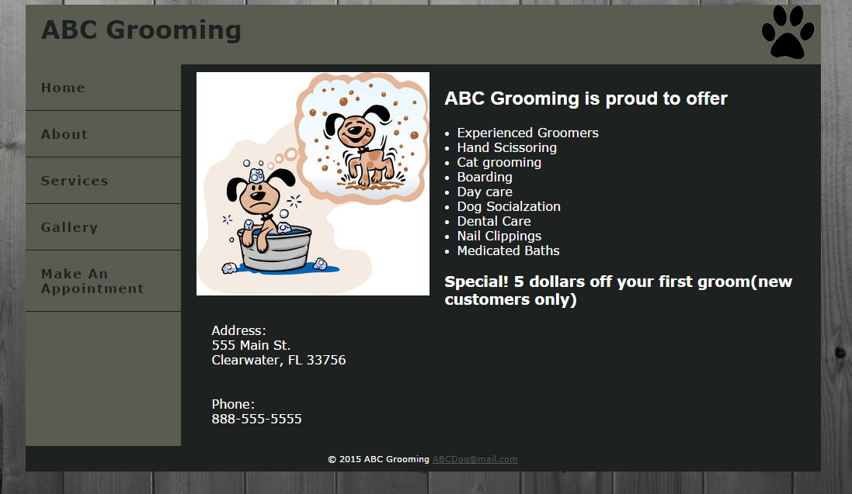

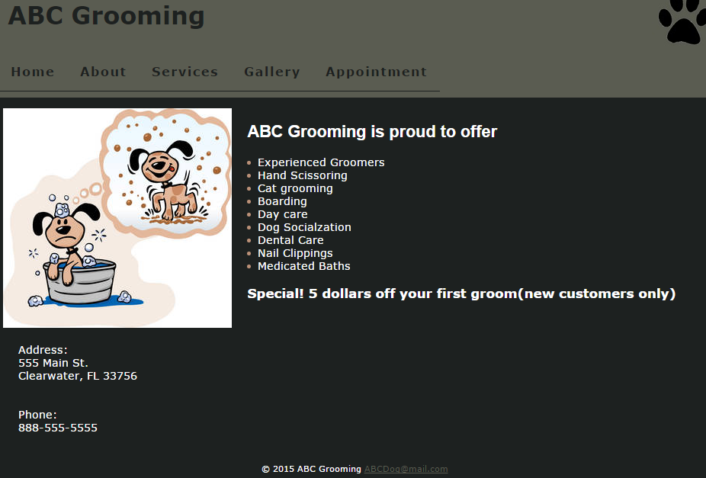

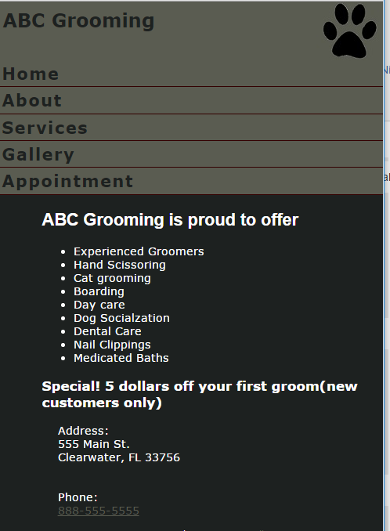

Layout 2:

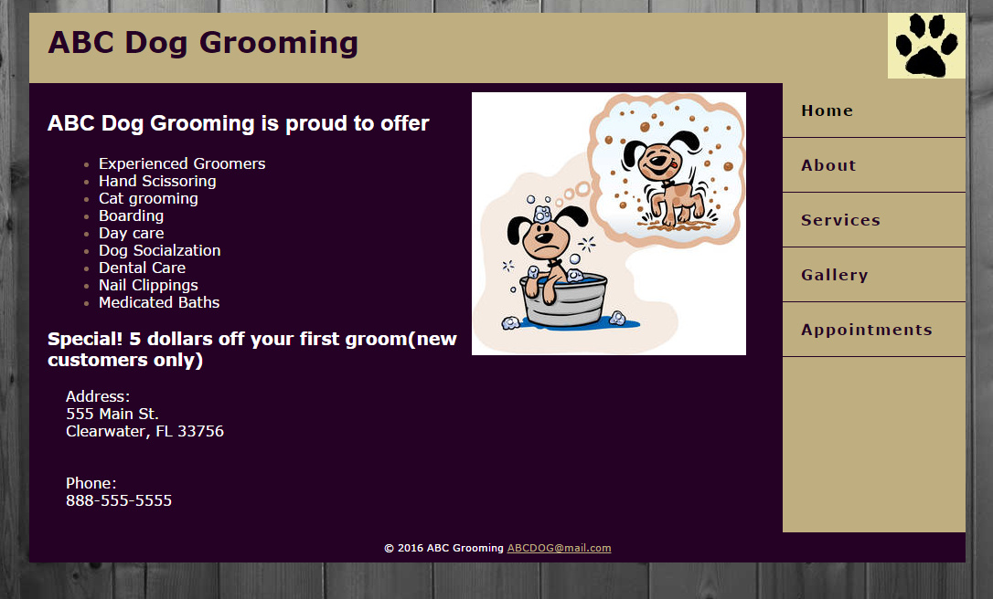

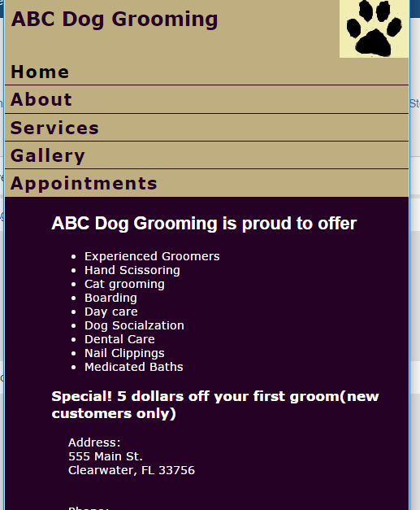

# References

Daddy, G. (n.d.). *Plesk Hosting*. Retrieved from Go Daddy: https://www.godaddy.com/hosting/plesk-hosting